Lab: Batch Processes

In this lab, you will create and run a batch process.

Requirements

This lab requires that you use TrainingApp 8.0, Guidewire Studio 8.0, and Chrome as your web browser. Start Guidewire Studio for Training App. Debug the Server.

To view, edit, and delete various contacts, log in to TrainingApp as Super User. The default URL for TrainingApp is <http://localhost:8880/ab/ContactManager.do>. The login/password for Super User is su/gw.

1. Batch process

In this exercise, you will create a batch process that creates a flag entry for when a doctor does not list a specialty.

All ABDoctors listed with Acme should have a category and specialty, however, the information is not always available when an ABDoctor is created or imported into the system.

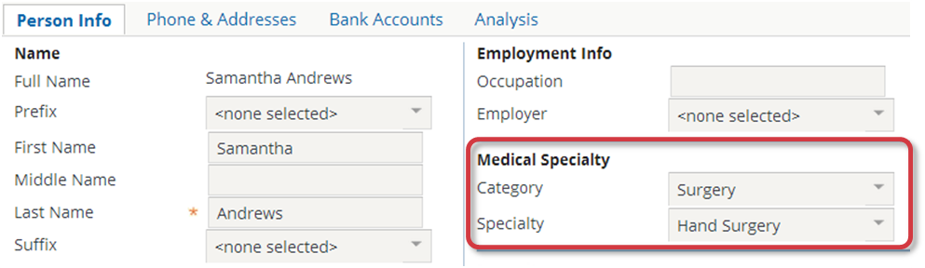

NOTE: For the entity ABDoctor, there are two fields in the Data Dictionary with similar names. Use ABDoctor.Specialty. Do not use ABDoctor.DoctorSpecialty.

To address the issue, Acme wants to run a batch process on a daily basis, during the early morning. The batch process should identify doctors whose specialty value is null and then create a flag entry for that doctor.

Tasks

1. Create a batch process that meets the following criteria:
2. Exists in the acmelab.ta.batch package.
3. Follows the recommended naming convention for batch processes.
4. Must be schedulable and executable from the batch process screen.
5. Must identify all ABDoctors who have no defined specialty.
6. If an identified doctor already has an open flag entry with the reason "doctor_specialty_unspecified", the batch process does **not** create an additional flag entry.
7. If an identified doctor has **NO** open flag entry with the reason "doctor_specialty_unspecified", the batch process creates a flag entry.
8. Modify the ProcessesPlugin plugin
9. In acme.ta.batch.ProcessesPlugin, modify the code to run your batch process.
10. Deploy your changes
11. Implement the necessary steps to deploy your batch process and related resources.

Verification

You will now verify that batch process meets the specified criteria.

1. Edit Samantha
2. In Details, in the Person Info card, select a Specialty.
3. Update the changes.
4. Edit Rebecca Stevens
5. In Details, in the Person Info card, select <none selected> for the Specialty.
6. Update the changes.
7. Run the batch process manually
8. To open Server Tools, use the key stroke: **ALT+SHIFT+T.**
9. Run your batch process.
10. Verify that a flag entry was NOT created for the Samantha Andrews
11. In the Actions menu, select Return to TrainingApp.
12. View the summary screen for Samantha Andrews.

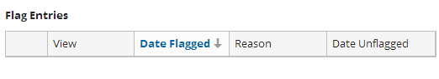

1. Verify that a flag entry was created for the Rebecca Stevens
2. View the summary screen for Rebecca Stevens.
3. Verify the flag entry for a "Doctor specialty is unspecified".

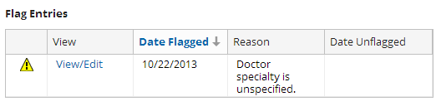

1. Resolve the flag entry, but do NOT specify a Specialty
2. Click the View/Edit button for the flag entry for Rebecca Stevens.
3. Enter any text in the Resolution field (such as "Resolved").
4. Click Update.
5. Run the batch process manually for a second time
6. Open Server Tools.
7. Run your batch process.
8. Verify that a second flag entry was related for the Rebecca Stevens
9. Return to TrainingApp.
10. View the summary screen for Rebecca Stevens.
11. Verify the second flag entry for a "Doctor specialty is unspecified".
12. Run the batch process manually for a third time
13. Open Server Tools.
14. Run your batch process.
15. Verify that there are only two flag entries for the Rebecca Stevens
16. Return to TrainingApp.
17. View the summary screen for Rebecca Stevens.
18. Verify that the batch process did NOT create an additional flag entries for a "Doctor specialty is unspecified".

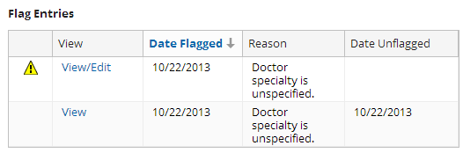

|  |  |
| --- | --- |
|  | Stop and ask your instructor to review your completed lab. |